METAFORGE IT SOLUTIONS
Recruiter Application Platform
MRAP
Recruitment Workflow
Executive Overview
For CEO · Super Admin · Admin Review

Field | Detail
Document Title | Recruitment Workflow — Executive Overview
Audience | CEO, Super Admin, Admin
Prepared by | Srikruthi, Harish
Purpose | Platform workflow review, operational understanding, project sign-off
Version | 1.0 — 2026
Classification | CONFIDENTIAL — Internal Use Only

1. Executive Summary
What This Platform Does
MRAP — the MetaForge Recruiter Application Platform — is a single digital system that manages every step of the recruitment process, from the moment a client sends a job requirement all the way to the day a new hire joins the company. It eliminates manual email chains, spreadsheet tracking, and WhatsApp coordination by replacing them with a structured, visible, and fully auditable platform.

The recruitment workflow covers 17 defined steps. Every step is tracked in the system — nothing falls through the cracks. Management can see the status of every requirement, every candidate, and every submission in real time, without asking the recruiter team for updates.

At any point where a candidate is rejected or drops out, the platform automatically loops back to the next available candidate — the requirement stays live and the process continues until a suitable candidate joins. The platform also manages all the exceptions and problems that commonly derail recruitment (duplicate submissions, client rejections, interview no-shows, candidate backouts) in a structured, trackable way.

1.1 Why This Matters for Leadership
Without MRAP | With MRAP
Requirements tracked in email threads and Excel | Every requirement has a unique ID, a status, and a complete history
No visibility into what each recruiter is working on | Real-time dashboard: who is working on what, at what stage
Duplicate candidate submissions discovered only after the fact | System blocks duplicates automatically before they happen
Interview feedback captured informally | Every interview round (L1, L2, L3), feedback, and outcome is logged
No clear picture of why positions take long to fill | Full pipeline visibility: where candidates are dropping out and why
Offer acceptances and backouts managed via WhatsApp | Offer status, acceptance, backout, and joining tracked in the system
Audit trail non-existent | Every action by every user is time-stamped and permanently recorded

2. How the Recruitment Workflow Works
Think of the recruitment workflow as a funnel. A job requirement from a client enters at the top. Candidates flow through a series of filters — screening, submission review, client shortlisting, interviews — until one candidate successfully joins. At every filter, if a candidate does not pass, the system returns to the candidate pool and tries the next best match. The requirement stays open until either a candidate joins or the client closes the position.

The Core Principle
If a candidate fails at any stage — screening, submission, client review, interview, or even after accepting an offer — the requirement does NOT close. The recruiter returns to the candidate pool and continues. The workflow only ends when (a) a candidate successfully joins, or (b) the client explicitly closes or cancels the requirement.

3. Complete Workflow Diagram
The diagram below shows the complete end-to-end recruitment workflow, including all exception paths and decision points. The left column shows the main workflow. The right column shows the major problems and exception scenarios tracked by the platform.

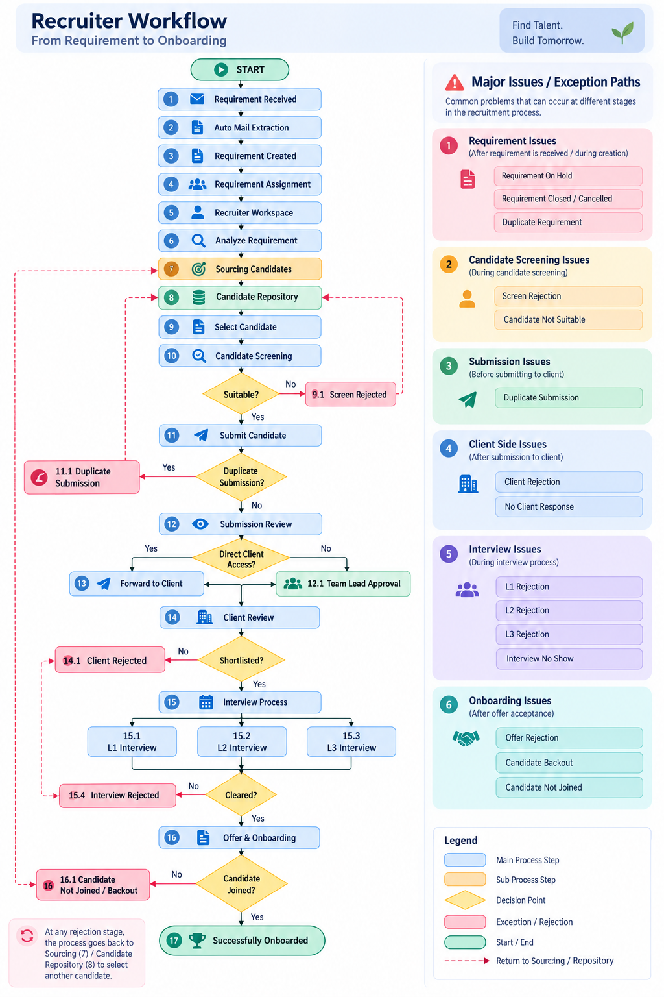

Figure 1 — MetaForge Recruiter Application Platform: Complete Recruitment Workflow

4. The 17 Stages — Plain Language Explanation
Below is a plain-language breakdown of every stage in the workflow. Each stage tells you what happens, what the system does automatically, and who is responsible.

1 | Requirement Received  A client sends a job requirement by email. This is the starting point for the entire recruitment lifecycle. The requirement contains job title, required skills, experience, location, salary, and open positions.  Who: System (auto), Admin

2 | Auto Mail Extraction  The platform reads the incoming email and automatically pulls out the requirement details — no manual copy-paste. Job title, skills, experience, location, salary range, and notice period are extracted and structured.  Who: System (automated)

3 | Requirement Created  A formal requirement record is created in the platform with a unique Requirement ID. It appears on the Requirements Dashboard and is ready for assignment. This gives management full visibility from day one.  Who: System (auto)

4 | Requirement Assignment  An Admin or Lead assigns the requirement to a specific recruiter. Once assigned, the recruiter receives access to the requirement and it appears in their personal workspace.  Who: Admin, Lead

5 | Recruiter Workspace  The recruiter's personal dashboard where they see all their assigned requirements, candidate progress, pending submissions, interview updates, and outcomes — everything in one place.  Who: Recruiter

6 | Analyze Requirement  The recruiter reads the requirement in detail: skills needed, experience level, location, employment type, salary expectations, and notice period. This analysis shapes the candidate search strategy.  Who: Recruiter

7 | Candidate Sourcing  The recruiter searches for candidates through external job platforms and internal sources. The goal is to find profiles that match the requirement criteria.  Who: Recruiter

8 | Candidate Repository  All sourced candidates are stored in the central candidate database. The recruiter can see each candidate's name, skills, experience, location, resume, availability, and submission history.  Who: System, Recruiter

9 | Candidate Selection  The recruiter reviews the available candidates and selects the most suitable profiles to move forward. Multiple candidates can be selected at once.  Who: Recruiter

10 | Candidate Screening  Before submitting a candidate to the client, the recruiter screens them against the requirement. If the candidate meets the criteria, they move forward. If not, they are marked as Screen Rejected and the recruiter selects the next candidate.  Who: Recruiter

11 | Submit Candidate  The screened candidate is submitted. Before submission, the system checks automatically whether this candidate has already been submitted for this requirement. If a duplicate is detected, the submission is blocked.  Who: Recruiter, System

12 | Submission Review  The submission is reviewed — either by the recruiter (if they have direct client access) or by the Team Lead (if approval is required). The candidate's profile, resume, and match details are checked before forwarding.  Who: Recruiter, Team Lead

13 | Forward to Client  The approved candidate profile is sent to the client. If the recruiter has direct client access, they send it directly. If not, the Team Lead reviews and approves first, then forwards to the client.  Who: Team Lead, Admin

14 | Client Review  The client reviews the candidate's profile and resume. Outcome: Shortlisted (candidate moves to interviews) or Client Rejected (recruiter returns to find another candidate).  Who: Client, Team Lead

15 | Interview Process  For shortlisted candidates, interviews are scheduled and tracked in the platform across three rounds. Each round (L1, L2, L3) is logged with outcome. If rejected at any round, the recruiter returns to the candidate pool. If the candidate successfully clears all required interview stages, the candidate is marked as Selected and proceeds to the Offer & Onboarding stage.  Who: Team Lead, Admin

16 | Offer & Onboarding  For candidates who clear all interviews, the offer process begins: offer details, offer acceptance, documentation, verification, and joining. This entire final stage is tracked in the platform.  Who: Admin, Team Lead

17 | Successfully Onboarded  The candidate joins the organization. The requirement is fulfilled. The platform marks the candidate as Successfully Onboarded and the requirement can be closed.  Who: System, Admin

5. Decision Points — Where the Workflow Branches
At six critical points in the workflow, the system evaluates a condition and routes the process differently based on the outcome. These are the moments that determine whether a candidate moves forward or the recruiter needs to find someone else.

Decision Point | Condition Checked | If YES | If NO
After Screening (Step 10) | Is the candidate suitable for this requirement? | Move to submission process | Mark as Screen Rejected — return to Candidate Repository
After Submission (Step 11) | Has this candidate already been submitted for this requirement? | Block submission — select another candidate | Allow submission — proceed to Submission Review
At Submission Review (Step 12) | Does the recruiter have direct client access? | Forward to client directly (Step 13) | Submit to Team Lead for approval first (Step 12.1)
After Client Review (Step 14) | Has the client shortlisted the candidate? | Schedule interviews (Step 15) | Mark as Client Rejected — return to sourcing
After Interviews (Step 15) | Has the candidate cleared all interview rounds? | Move to Offer & Onboarding (Step 16) | Mark as Interview Rejected — return to sourcing
After Offer & Onboarding (Step 16) | Has the candidate successfully joined? | Mark as Successfully Onboarded — requirement fulfilled | Mark as Candidate Not Joined / Backout — return to sourcing

6. Exception Handling — What Can Go Wrong and How It's Managed
Recruitment rarely goes perfectly. The platform is built to handle all the common problems that arise at every stage. Instead of these problems breaking the process, they are tracked, managed, and the workflow continues. Below are all six categories of exceptions the platform handles.

Exception Category 1 — Requirement Issues
These are problems that occur before or during the recruitment process at the requirement level.

Requirement Issues
• Requirement On Hold — The client temporarily pauses hiring. The requirement status is set to "On Hold". All recruitment activity for this requirement is paused until the client reactivates it.
• Requirement Closed / Cancelled — The client no longer needs the position filled. The requirement is closed. Recruiters stop sourcing and submitting candidates for it.
• Duplicate Requirement — The same requirement email arrives more than once. The system identifies potential duplicates to prevent recruiters from working on the same position twice.

Exception Category 2 — Candidate Screening Issues
These problems occur during the internal screening step, before the candidate reaches the client.

Candidate Screening Issues
• Screen Rejection — The candidate does not meet the basic requirement criteria. They are rejected at the screening stage. The recruiter returns to the Candidate Repository to find the next candidate.
• Candidate Not Suitable — The candidate may not match due to: skill mismatch, experience level too low or too high, wrong location, unavailability, or notice period too long. These reasons are trackable.

Exception Category 3 — Submission Issues
This problem occurs when a candidate is being submitted to the client.

Submission Issues
• Duplicate Submission — The same candidate has already been submitted for this specific requirement. The platform detects this automatically and blocks the submission before it happens. The recruiter is directed to select a different candidate.

Exception Category 4 — Client-Side Issues
These are problems that arise after the candidate reaches the client.

Client-Side Issues
• Client Rejection — Client rejection is logged and the recruiter returns to sourcing. For no response, the submission remains pending and trackable for follow-up.

Exception Category 5 — Interview Issues
These are problems that occur during the interview rounds.

Interview Issues
• L1 Rejection — The candidate did not pass the first round interview. Recruiter returns to sourcing.
• L2 Rejection — The candidate did not pass the second round interview. Recruiter returns to sourcing.
• L3 Rejection — The candidate did not pass the final round interview. Recruiter returns to sourcing.
• Interview No Show — The candidate did not appear for the scheduled interview. This is tracked separately. Recruiter returns to sourcing.

Exception Category 6 — Onboarding Issues
These are the most costly exceptions — they occur after a candidate has been selected and offered the position.

Onboarding Issues
• Offer Rejection — The candidate receives the offer but declines it. The recruiter must return to sourcing. All previous effort is preserved in the system for reference.
• Candidate Backout — The candidate initially accepts the offer but withdraws before the joining date. This is tracked separately from an offer rejection.
• Candidate Not Joined — The candidate fails to show up on the joining date without formally declining. This outcome is tracked and the requirement is reopened.

Key Management Insight
Every exception is logged with a timestamp, the responsible user, and the specific reason. This means management can see — by requirement, by recruiter, and by time period — exactly where candidates are dropping out. This data drives performance improvement and process corrections.

7. Complete Workflow at a Glance
The table below gives a complete one-line view of all 17 stages, who owns each stage, and what the system does automatically at each step.

Stage | Step Name | Who Acts | What the System Does
1 | Requirement Received | System | Email arrives from client — process begins
2 | Auto Mail Extraction | System (auto) | Reads email, extracts all requirement details automatically
3 | Requirement Created | System (auto) | Creates requirement record with unique ID; visible to management
4 | Requirement Assignment | Admin / Lead | Assigns requirement to a recruiter; recruiter gets access
5 | Recruiter Workspace | Recruiter | Recruiter's personal dashboard shows all assigned work
6 | Analyze Requirement | Recruiter | Recruiter studies requirement details before sourcing
7 | Candidate Sourcing | Recruiter | Recruiter searches for matching candidates externally and internally
8 | Candidate Repository | System / Recruiter | Central candidate database; full profiles and history visible
9 | Candidate Selection | Recruiter | Recruiter selects the best-matching candidates from the repository
10 | Candidate Screening | Recruiter | Internal check: does this candidate meet the requirement?
11 | Submit Candidate | Recruiter / System | System auto-checks for duplicates; submission created if clear
12 | Submission Review | Recruiter / Team Lead | Profile, resume, and match details reviewed before forwarding
13 | Forward to Client | Team Lead / Admin | Candidate profile sent to client (direct or after Lead approval)
14 | Client Review | Client / Team Lead | Client shortlists or rejects; outcome logged immediately
15 | Interview Process (L1/L2/L3) | Team Lead / Admin | All 3 interview rounds tracked with outcomes and feedback
16 | Offer & Onboarding | Admin / Team Lead | Offer, acceptance, documentation, verification, joining tracked
17 | Successfully Onboarded | System / Admin | Candidate joined; requirement fulfilled; platform records closed

8. Exception Summary — Management Reference
Exception Category | What Can Go Wrong | What the Platform Does
Requirement Issues | On Hold, Closed / Cancelled, Duplicate | Status tracked; recruitment paused automatically; duplicates flagged
Candidate Screening | Screen Rejection, Candidate Not Suitable | Candidate marked with reason; recruiter returns to candidate pool
Submission Issues | Duplicate Submission | System blocks the submission automatically before it is sent
Client-Side Issues | Client Rejection, No Client Response | Client rejection logged; recruiter returns to sourcing. No response: submission remains pending and trackable for follow-up.
Interview Issues | L1 / L2 / L3 Rejection, No Show | Each round outcome logged; recruiter returns to sourcing automatically
Onboarding Issues | Offer Rejection, Backout, Not Joined | Each outcome tracked separately; requirement reopened for new candidates

The Golden Rule
A requirement never fails because one candidate failed. It only closes when the client decides to close it. Until then, the platform keeps the recruitment process moving, one candidate at a time.

9. What Super Admin & Admin Can See
As Super Admin or Admin, you have complete visibility across the entire platform. Here is what you can access at any time, without asking anyone:

9.1 Real-Time Dashboards
- Every active requirement with its current status (Open, On Hold, Closed).
- Every recruiter's current workload — how many requirements they are working on.
- Every candidate in the pipeline — which stage they are at right now.
- All pending submissions waiting for Team Lead approval.
- Upcoming interview schedules across all requirements.
- All open offers waiting for candidate acceptance.

9.2 Performance Metrics
- How many requirements each recruiter has been assigned this month.
- How many candidates each recruiter sourced and submitted.
- How many submissions were approved vs rejected by Team Leads.
- What percentage of submissions reached the client interview stage.
- Average time from requirement assignment to first candidate submission.
- Offer acceptance and backout rates — by recruiter and by client.

9.3 Exception Tracking
- Which requirements are on hold and for how long.
- How many duplicate submissions were blocked by the system.
- Which clients have not responded to submissions and for how many days.
- Where candidates are most frequently dropping out (screening, interviews, or onboarding).
- All candidate backouts and no-shows with timestamps and responsible recruiter.

9.4 Complete Audit Trail
Every single action on the platform is permanently recorded: who did it, when they did it, what changed, and what the previous value was. This means:
- Any disputed decision can be reviewed with complete accuracy.
- All client submissions are logged with timestamps — no "I sent it" without proof.
- All candidate rejections include the reason — no ambiguity.
- All status changes are traceable to the specific user who made them.

10. Who Does What — Role Summary
Role | What They Do in This Workflow | What They Can See
Super Admin (CEO Level) | Full platform access; organization-wide settings; user and role management; all reports and audit logs | Everything — all requirements, all candidates, all submissions, all recruiters, all reports
Admin | Create and manage requirements; assign recruiters; approve or forward submissions; manage offer and onboarding process; run reports | Everything — same as Super Admin for operational data
Team Lead (Lead) | Review and approve recruiter submissions; forward to clients; schedule interviews; manage offer process; view team performance | All data for their team — their team's requirements, submissions, and candidates
Recruiter | Source candidates; screen and submit candidates for assigned requirements; track their own submissions and interviews | Only their assigned requirements and their own submissions — cannot see other recruiters' work

11. Key Principles of This Platform

Principle 1 — No Requirement Is Ever Lost
Every requirement has a unique ID and a real-time status. Management can see every requirement's age, current stage, and assigned recruiter at any time. Nothing is sitting in someone's email inbox without the platform knowing about it.

Principle 2 — No Candidate Submission Can Be Duplicated
The platform automatically checks and blocks duplicate submissions before they happen. This prevents the embarrassing and relationship-damaging situation of sending the same candidate to a client twice.

Principle 3 — Every Rejection Has a Reason
Whether a candidate is rejected at screening, by the client, or at an interview, the reason is recorded. Over time, this builds a picture of which rejection reasons are most common — and why — enabling process improvement.

Principle 4 — Failures Do Not Stop the Process
When a candidate fails at any stage, the system loops back to the candidate pool. The requirement continues. The recruiter is guided back to the next candidate automatically. The requirement only closes when the client closes it or a candidate successfully joins.

Principle 5 — Management Has Full Visibility at All Times
Super Admin and Admin users do not need to ask recruiters for status updates. The platform provides real-time dashboards, performance reports, exception tracking, and a complete audit trail — all accessible without any coordination with the recruitment team.

MetaForge IT Solutions — MRAP Recruitment Workflow Executive Overview
v1.0 | 2026 | CONFIDENTIAL — For CEO, Super Admin & Admin Review Only

